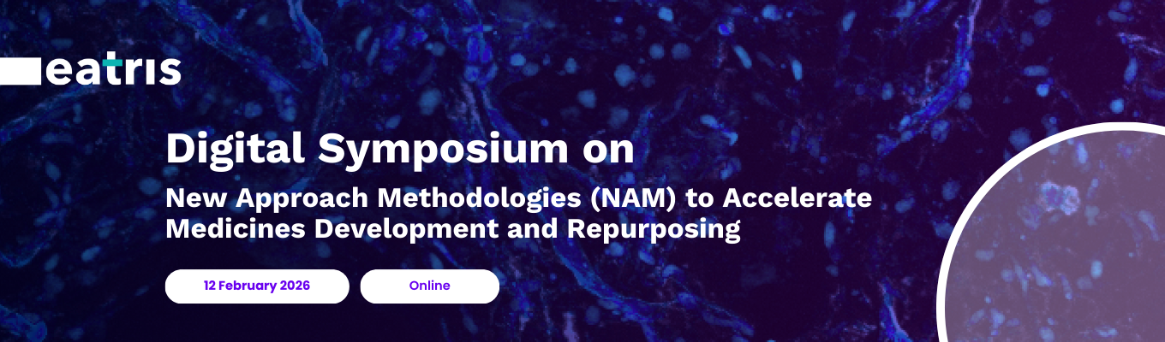

12 February 2026, 1300-1600 (CET)

Register for the Symposium here

Agenda
13:00-13:10 - Welcome
Martin de Kort, PhD, Scientific Lead Medicines Development, EATRIS
Maddalena Fratelli, PhD, Mario Negri Institute, Milan, Italy, co-chair EATRIS Small Molecules Platform

13:10-13:35 - Keynote 1
Ombion - Centre for Animal-Free Biomedical Translation
Prof. Daniela Salvatori, Scientific Director (NL)

13.35-13.40 - Introduction
Sílvia Almeida, Chief Scientific Officer, CoLAB Accel Bio (PT)

13:40-13:55 - Abstract presentation 1
Engineering advanced human kidney organoids for assessing drug-induced toxicity
Cláudia Miranda, Researcher - Advanced in vitro Systems, CoLAB Accel Bio (PT)
13:55-14:10 - Abstract presentation 2
Functional precision medicine screening reveals personalised therapeutic vulnerabilities in adult high-grade glioma subtypes
Anuja Lipsa, Postdoctoral fellow, Luxembourg Institute of Health (LU)

14:10-14:25 - Abstract presentation 3
The development of virtual reality drug combiner from the DTRIP4H project
Jing Tang, Associate Professor, University of Helsinki (FI)

14.25 - Coffee break

14:35-15:00 - Keynote 2
European Commission Joint Research Centre
Prof. Maurice Wehlan, Deputy Director, Head of Unit (JRC) (IT)

15:00-15:15 - Abstract presentation 4
In vitro organotypic cultures for the evaluation of anti-tumor drug sensitivity
Gabriela Paroni, Staff Scientist, Mario Negri Institute for Pharmacological Research IRCCS (IT)

15:15-15:30 - Abstract presentation 5
A Translational Biomarker-Based Approach to Identify Blood-Brain Barrier Dysfunction and Infarct Expansion After Ischemic Stroke
Ramón Iglesias Rey, Researcher, Health Research Institute of Santiago de Compostela (ES)

15:30-15:45 - Abstract presentation 6
Accelerating Leigh syndrome treatments using patient-derived pluripotent stem cell models
Alessandro Prigione, Principal Investigator, Heinrich Heine University (HHU), Düsseldorf (DE)

15:45-16:00 - Open discussion
Martin de Kort, PhD, EATRIS; all participants

16:00 - Final remarks and close

