Multidisciplinary flagship COMPASS-AI project kicks off under EU’s Apply AI Strategy

21 October 2025

The COMPASS-AI consortium and the European Commission are excited to announce the official launch of the COMPASS-AI Project “Community Of Multidisciplinary Professionals Advancing Safe and Successful AI Implementation in Clinical Practice”, a flagship project under the EU’s Apply AI Strategy to accelerate the safe and effective deployment of AI systems in clinical settings to benefit Europe’s patients and citizens.
The 4-year project co-funded under the EU4Health programme focuses on practical implementation of best practices in AI deployment in healthcare by developing scalable, equitable solutions, with a focus on cancer care and remote regions.
It will build, expand and sustain a multidisciplinary community of experts, including healthcare professionals, patient representatives, AI developers, IT specialists, hospital managers, regulators, ethicists, economists and policymakers, who will leverage their collective expertise to identify challenges, enablers, and actionable strategies for AI implementation.
COMPASS-AI will define evidence-based AI deployment guidelines for Europe and validate them through four pilot studies conducted across European countries, in diverse healthcare environments, covering radiology, pathology, surgery and both hospital and general practice settings.
A sustainable, interactive digital platform will host best practices, foster collaboration and knowledge exchange, and offer educational programs tailored to stakeholder needs to improve AI literacy.
The project is coordinated by the Maastricht University Medical Center, sharing scientific coordination with the Netherlands Cancer Institute, with the European Institute for Biomedical Imaging Research (EIBIR) as lead partner for management and dissemination.
“We are honoured to lead this flagship project that will deliver the foundations for exchanging best practices and speed up safe, scalable and equitable AI deployment in healthcare across Europe”, Prof. Regina Beets-Tan and Dr. Laurens Topff, Scientific Coordinators of the project, stated at the kick-off meeting.

The project will build upon FUTURE-AI, an established framework for trustworthy AI in healthcare and align with the EU’s Apply AI strategy as well as related European digital health legislation, reinforcing its strategic relevance for advancing health innovation across Europe.
“The European Commission welcomes the launch of COMPASS-AI, one of the flagship projects underpinning the Apply AI Strategy published on 10 October 2025. COMPASS-AI will support the safe, efficient and effective integration of artificial intelligence into clinical practice, delivering tangible benefits for patients across Europe”, according to Yiannos Tolias, legal lead on AI and AI liability in Healthcare at the European Commission DG SANTE.
COMPASS-AI will further align with Cancer Image Europe as enabling infrastructure to aid AI implementation and deployment in clinics by leveraging its best practices in interoperability and data sharing.

Contact information
office@eibir.org
More information on the project as well as its partners at https://www.eibir.org/projects/compass-ai/
COMPASS-AI LinkedIn account: https://www.linkedin.com/showcase/compassai-health/about/


COMPASS-AI is co-funded under the EU4Health Programme 2021–2027 under grant agreement no. 101233553. Funded by the European Union. Views and opinions expressed are however those of the author(s) only and do not necessarily reflect those of the European Union or European Health and Digital Executive Agency. Neither the European Union nor the granting authority can be held responsible for them.

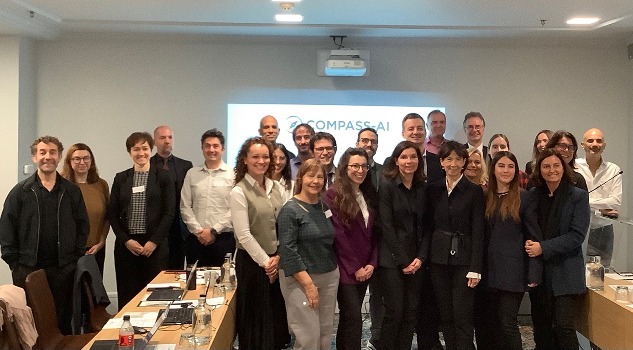
COMPASS-AI Kick-off Meeting, Brussels/BE, 20 October 2025 with high-level representatives from the European Commission and HaDEA.

