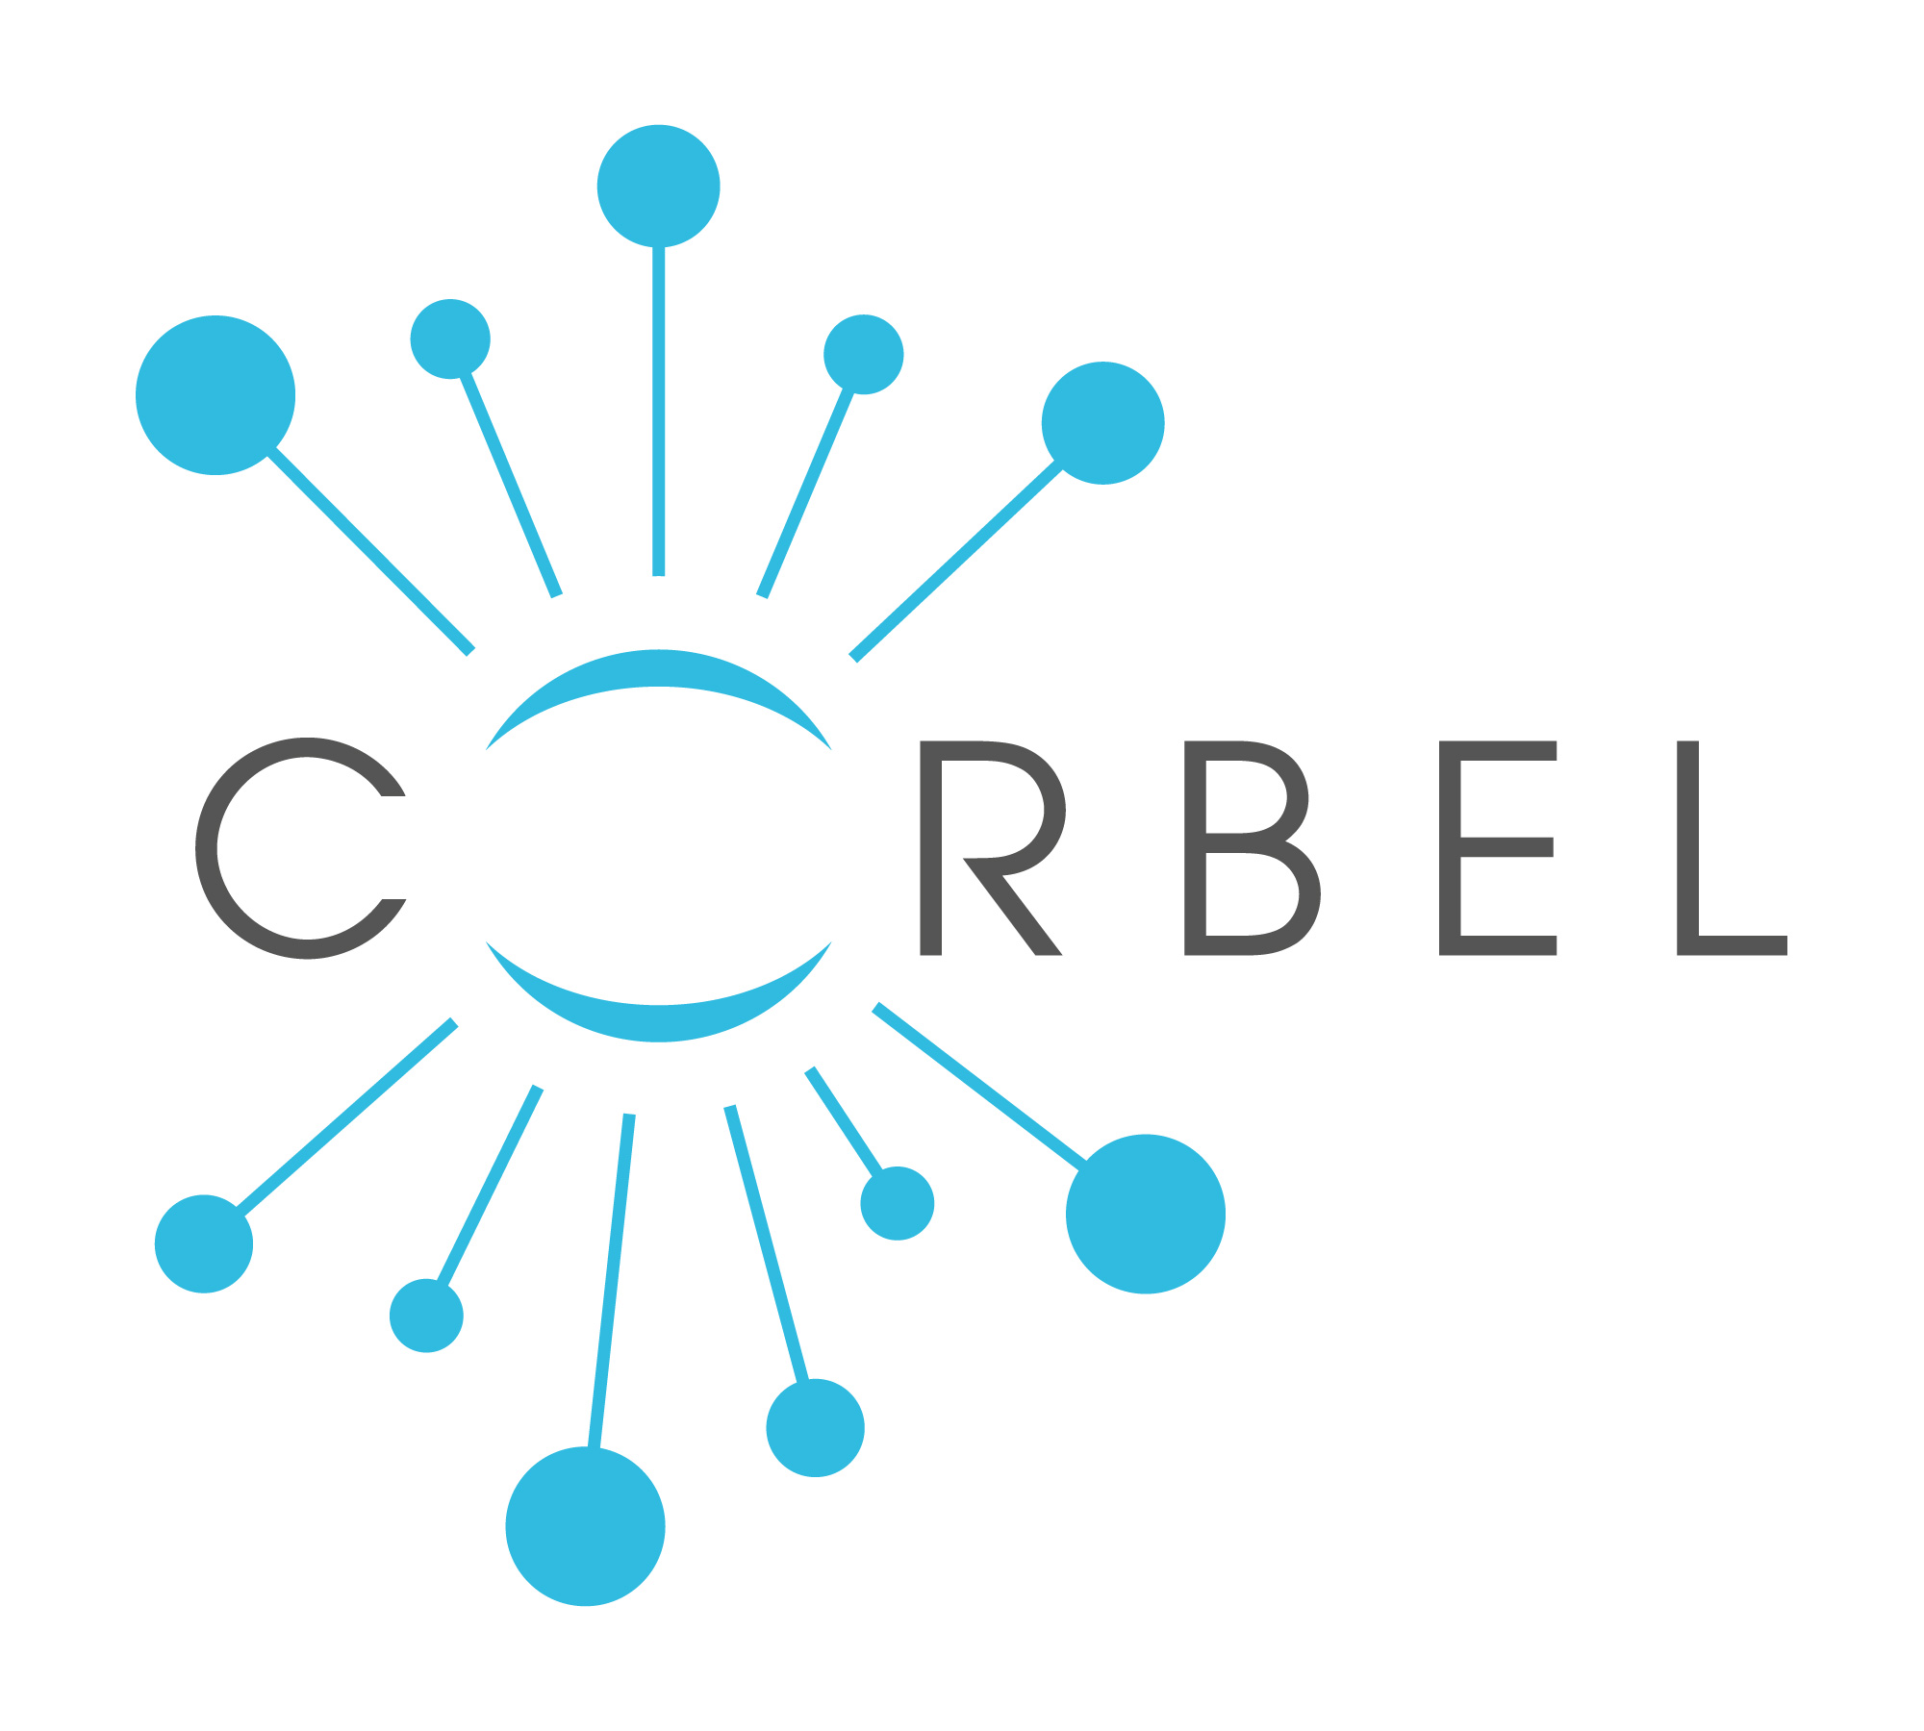

Biological MATERIAL TRANSFER AGREEMENT

THE UNDERSIGNED:

- name of provider, located at xxx, represented by its xxx hereinafter “xxx”;

and

- name of recipient, located at xxx, represented by its xxx hereinafter “xxx”;

HAVE AGREED AS FOLLOWS:

Article 1. Definitions
1.1. Provider: Organisation providing the Original Material. The name and address of this party will be specified in Article 3.1.
1.2. Provider Scientist: The name and address of this party will be specified in Article 3.1.
1.3. Recipient: Organisation receiving the Original Material. The name and address of this party will be specified in Article 3.2.
1.4. Recipient Scientist: The name and address of this party will be specified in Article 3.2.
1.5. Original Material: The description of the material being transferred will be specified in Article 3.3.
1.6. Material: Original Material, Progeny, and Unmodified Derivatives. The Material shall not include:
(a) Modifications, or
(b) other substances created by the Recipient through the use of the Material which are not Modifications, Progeny or Unmodified Derivatives.
1.7. Progeny: Unmodified descendant from the Material, such as virus from virus, cell from cell, or organism from organism.
1.8. Unmodified Derivatives: Substances created by the Recipient which constitute an unmodified unctional subunit or product expressed by the Original Material. Some examples include: subclones of unmodified cell lines, purified or fractionated subsets of the Original Material, proteins expressed by DNA/RNA supplied by the Provider, or monoclonal antibodies secreted by a hybridoma cell line.
1.9. Modifications: Substances created by the Recipient which contain/incorporate the Material.
1.10. Commercial Purposes: The sale, lease, license, or other transfer of the Material or Modifications to a for-profit organisation. Commercial Purposes shall also include uses of the Material or Modifications by any organisation, including Recipient, to perform contract research, to screen compound libraries, to produce or manufacture products for general sale, or to conduct research activities that result in any sale, lease, license, or transfer of the Material or Modifications to a for-profit organisation. However, industrially sponsored academic research shall not be considered a use of the Material or Modifications for Commercial Purposes per se, unless any of the above conditions of this definition are met.

Article 2. Terms and Conditions of this Agreement
2.1. The Provider retains ownership of the Material, including any Material contained or incorporated in Modifications.
2.2. The Recipient retains ownership of:
(a) Modifications (except that, the Provider retains ownership rights to the Material included therein), and
(b) those substances created through the use of the Material or Modifications, but which are not Progeny, Unmodified Derivatives or Modifications (i.e., do not contain the Original Material, Progeny, Unmodified Derivatives).
If either 2.2 (a) or 2.2 (b) results from the collaborative efforts of the Provider and the Recipient, joint ownership may be negotiated.
2.3. The Recipient and the Recipient Scientist agree that the Material:
(a) is to be used solely for academic or other non-commercial research purposes;
(b) will not be used in human subjects, in clinical trials, or for diagnostic purposes involving human subjects without the written consent of the Provider;
(c) is to be used only at the Recipient organisation and only in the Recipient Scientist's laboratory under the direction of the Recipient Scientist or others working under his/her direct supervision; and
(d) will not be transferred to anyone else within the Recipient organisation without the prior written consent of the Provider.
When relevant in case of human biological material, the Provider shall check prior to the signature of this agreement that:
- the proposed usage is covered by the informed consent of the persons who provided their material
- any necessary ethics or regulatory approval for the proposed use is provided by the Recipient
- the legal provisions for export (Provider site) and import (Recipient site) of biological material are fulfilled.
2.4. The Recipient and the Recipient Scientist agree to refer to the Provider any request for the Material from anyone other than those persons working under the Recipient Scientist's direct supervision. To the extent supplies are available, the Provider or the Provider Scientist agrees to make the Material available, under a separate implementing letter to this Agreement or other agreement having terms consistent with the terms of this Agreement, to other scientists (at least those at Non-profit Organisation(s)) who wish to replicate the Recipient Scientist's research; provided that such other scientists reimburse the Provider for any costs relating to the preparation and distribution of the 2.5.
2.5. The Recipient and/or the Recipient Scientist shall have the right, without restriction, to distribute substances created by the Recipient through the use of the Original Material only if those substances are not Progeny, Unmodified Derivatives, or Modifications.
2.6. Under a separate implementing letter to this Agreement (or an agreement at least as protective of the Provider's rights), the Recipient may distribute Modifications to Non-profit Organisation(s) for research and teaching purposes only.
2.7. Without written consent from the Provider, the Recipient and/or the Recipient Scientist may NOT provide Modifications for Commercial Purposes. It is recognized by the Recipient that such Commercial Purposes may require a commercial license from the Provider and the Provider has no obligation to grant a commercial license to its ownership interest in the Material incorporated in the Modifications. Nothing in this paragraph, however, shall prevent the Recipient from granting commercial licenses under the Recipient’s intellectual property rights claiming such Modifications, or methods of their manufacture or their use.
2.8. The Recipient acknowledges that the Material is or may be the subject of a patent application. Except as provided in this Agreement, no express or implied licenses or other rights are provided to the Recipient under any patents, patent applications, trade secrets or other proprietary rights of the Provider, including any altered forms of the Material made by the Provider. In particular, no express or implied licenses or other rights are provided to use the Material, Modifications, or any related patents of the Provider for Commercial Purposes.
2.9. If the Recipient desires to use or license the Material or Modifications for Commercial Purposes, the Recipient agrees, in advance of such use, to negotiate in good faith with the Provider to establish the terms of a commercial license. It is understood by the Recipient that the Provider shall have no obligation to grant such a license to the Recipient, and may grant exclusive or non-exclusive commercial licenses to others, or sell or assign all or part of the rights in the Material to any third party(ies), subject to any pre-existing rights held by others.
2.10. The Recipient is free to file patent application(s) claiming inventions made by the Recipient through the use of the Material but agrees to notify the Provider upon filing a patent application claiming Modifications or method(s) of manufacture of the Material.
2.11. Any Material delivered pursuant to this Agreement is understood to be experimental in nature and may have hazardous properties. The Provider makes no representations and extends no warranties of any kind, either expressed or implied. There are no express or implied warranties of merchantability or fitness for a particular purpose, or that the use of the material will not infringe any patent, copyright, trademark or other proprietary rights.
2.12. Except to the extent prohibited by law, the Recipient assumes all liability for damages which may arise from its use, storage or disposal of the Material. The Provider will not be liable to the Recipient for any loss, claim or demand made by the Recipient, or made against the Recipient by any other party, due to or arising from the use of the Material by the Recipient, except to the extent permitted by law when caused by the gross negligence or wilful misconduct of the Provider.
2.13. This agreement shall not be interpreted to prevent or delay publication of research findings resulting from the use of the Material or the Modifications. The Recipient Scientist agrees to provide appropriate acknowledgment of the source of the Material in all publications. The bioresource from which the material is originating XXX requires to be cited according to the CoBRA (Citation of BioResource in journal Articles) guideline in any publication referring to it. [Here the Provider could specify what would be this citation format for the specific resource object of the MTA, i.e. which name, which ID etc.]
2.14. The Recipient agrees to use the Material in compliance with all applicable statutes and regulations, including Public Health Service and National Institutes of Health regulations and guidelines such as, for example, those relating to research involving the use of animals or recombinant DNA. The Recipient is aware that for microbial genetic resources as well as plant material specific requirements may be compulsory to ensure the use of the Material in compliance with the Convention on Biological Diversity (CBD), the Nagoya Protocol on Access to Genetic Resources and the Fair and Equitable Sharing of Benefits Arising from Their Utilization and underlying international and national laws.
2.15. This Agreement will terminate on the earliest of the following dates:
(a) when the Material becomes generally available from third parties, for example, though reagent catalogues or public depositories or
(b) on completion of the Recipient's current research with the Material, or
(c) on thirty (30) days written notice by either party to the other, or
(d) on the date specified in an implementing letter, provided that:
(I) if termination should occur under 2.15(a), the Recipient shall be bound to the Provider by the least restrictive terms applicable to the Material obtained from the then available resources;
(II) if termination should occur under 2.15(b) or (d) above, the Recipient will discontinue its use of the Material and will, upon direction of the Provider, return or destroy any remaining Material. The Recipient, at its discretion, will also either destroy the Modifications or remain bound by the terms of this agreement as the apply to Modifications; and
(III) in the event the Provider terminates this Agreement under 2.15(c) other than for breach of this Agreement or for cause such as an imminent health risk or patent infringement, the Provider will defer the effective date of termination for a period of up to one year, upon request from the Recipient, to permit completion of research in progress. Upon the effective date of termination, or if requested, the deferred effective date of termination, Recipient will discontinue its use of the Material and will, upon direction of the Provider, return or destroy any remaining Material. The Recipient, at its discretion, will also either destroy the Modifications or remain bound by the terms of this agreement as they apply to Modifications.
2.16. Paragraphs 2.8, 2.11 and 2.12 shall survive termination.
2.17. The Material is provided at no cost, or with an optional transmittal fee solely to reimburse the Provider for its preparation and distribution costs. If a fee is requested by the Provider, the amount will be indicated in Article 3.4.

Article 3. Details Provider, details Recipient and description Original Material
3.1. Provider: Organisation providing the Original Material:
Organisation: xxx
Provider Scientist:
Name: xxx
Title: xxx
3.2. Recipient: Organisation receiving the Original Material:
Organisation: xxx
Recipient Scientist: xxx
Name: xxx
Title: xxx
3.3. Original Material: xxx
3.4. Transmittal Fee to reimburse the Provider for preparation and distribution costs (optional).
Amount: xxx

Article 4. Effective Date
4.1. This agreement will become effective when signed by all parties.

Article 5. Law
5.1. This agreement shall be interpreted, governed and enforced exclusively in accordance with XXX law.
5.2. All disputes between the Parties related to this Agreement, are to be instituted by the competent Court in XXX.

Agreed and signed in duplicate,
Provider Recipient

Provider Scientist Recipient Scientist

Checklist: http://www.equator-network.org/reporting-guidelines/cobra/ Full guideline at http://bmcmedicine.biomedcentral.com/articles/10.1186/s12916-015-0266-y

